**R Programming Assignment**20 Points

Due: 2/27

1. Run the R code given below and consider the vector and the two matrices:

a <- c(2, 4, 6, 8, 10, 12); a

A <- matrix(a,4,2); A

B <- matrix(a,3,4); B

* 1. What is the length of the vector? How does the length of the vector compare to the dimensions of the two matrices? How did R handle any discrepancies? Did it differ between the two matrices – if so, how?
  2. Using the information obtained in part (a) provide the R code to create the matrix given below.

|  |  |  |  |  |  |
| --- | --- | --- | --- | --- | --- |
|  | [,1] | [,2] | [,3] | [,4] | [,5] |
| [1,] | -2 | -1 | 0 | 1 | 2 |
| [2,] | -2 | -1 | 0 | 1 | 2 |
| [3,] | -2 | -1 | 0 | 1 | 2 |

1. Consider the screenshots given below.
   1. Create the objects shown below.

R Screenshot:

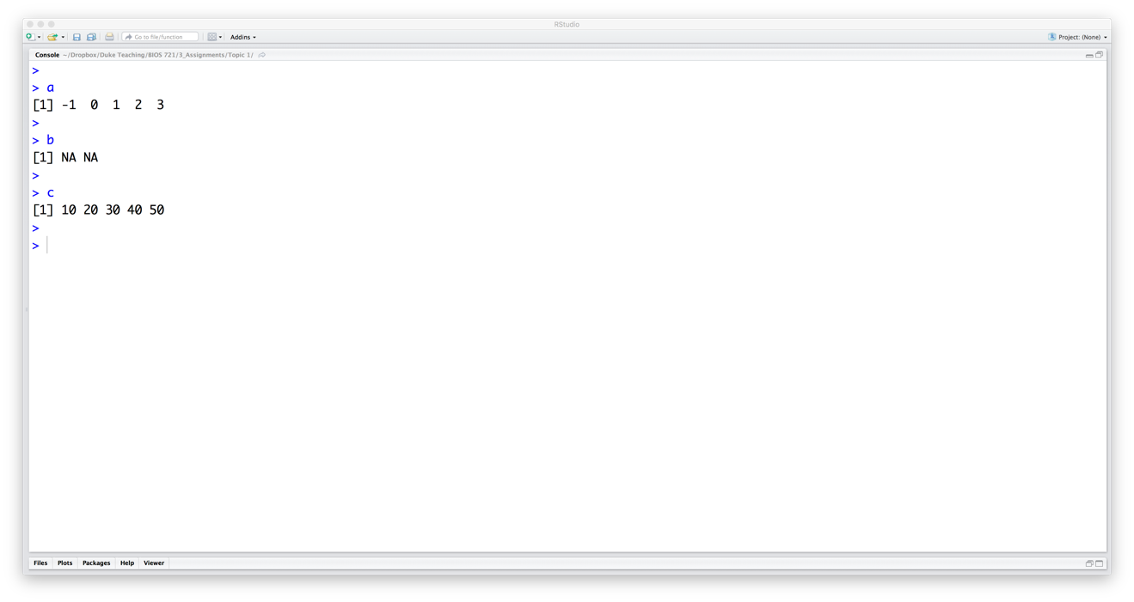

* 1. Using the objects created in part (a) create the objects shown below.

R Screenshot:

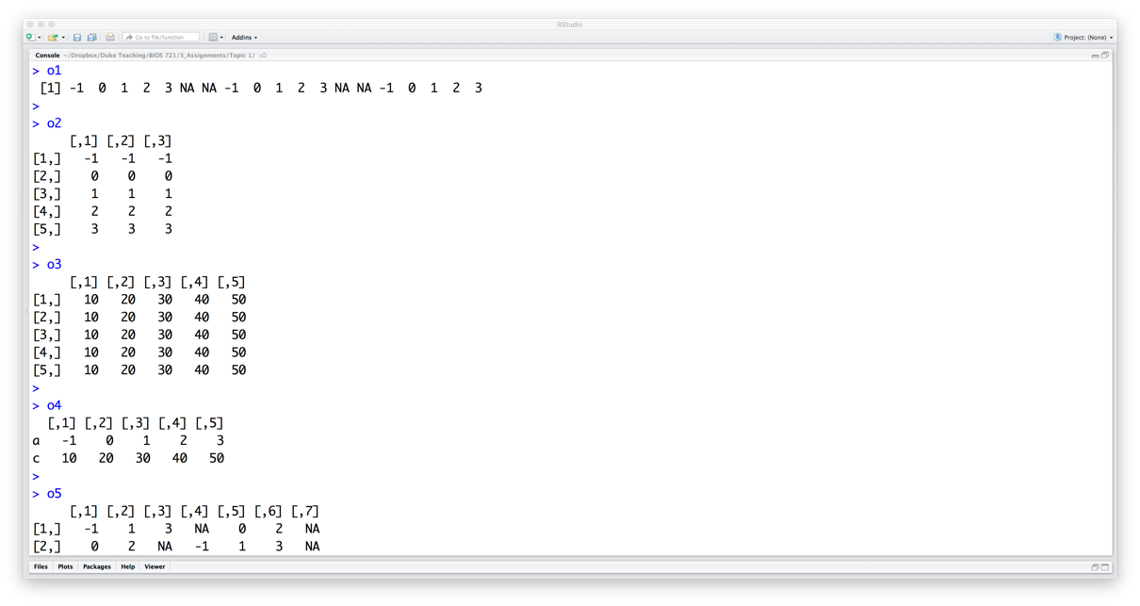

1. Create the objects shown in the screenshots below.

R Screenshots:

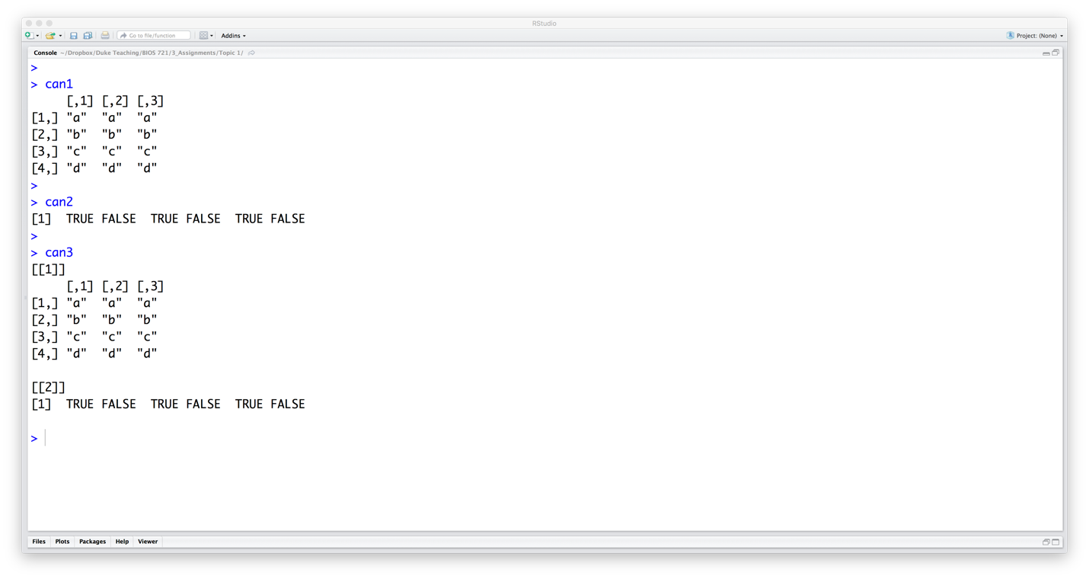

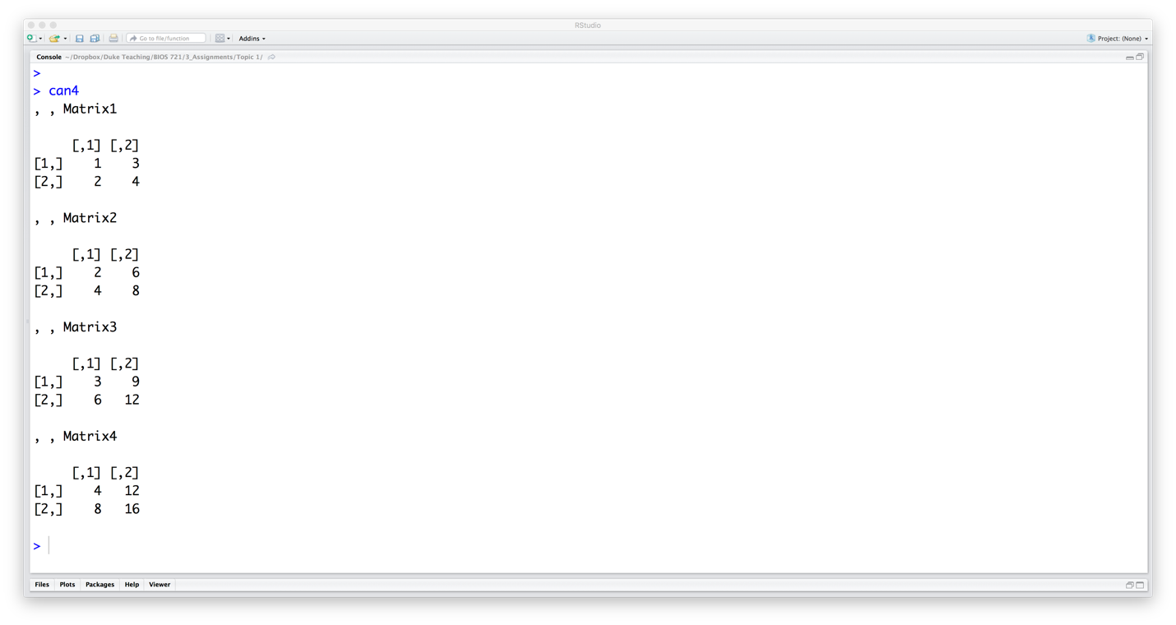

1. Consider the data set given below. It lists 5 students’ scores on three tests and on a final exam in a course:

|  |  |  |  |  |
| --- | --- | --- | --- | --- |
| ID | Test1 | Test2 | Test3 | Final |
| Student1 | 20 | 23 | 18 | 48 |
| Student2 | 16 | 15 | 18 | 36 |
| Student3 | 25 | 20 | 22 | 40 |
| Student4 | 14 | 19 | 18 | 42 |
| Student5 | 10 | 15 | 14 | 30 |

* 1. Create a data object that contains the same information as the data set shown above. Call the data object grades. Make sure that the type of each data element is appropriate. Print the grades object to the console.
  2. Suppose that Student 1 actually received a 21 on Test 3. Update the grades data object to reflect the correct score by changing that value only (in other words, without redefining the entire grades object). Print the updated grades object to the console.
  3. Print all the grades for …
     1. Test 3
     2. Student 4
     3. Test 1 – 3 but not for the final exam.
  4. Write the grades object to a .csv file named “grades.csv.” Be sure to write row names and column names to the file.

1. Consider the vector: X <- c(7, 12, 9, 15, NA, 8, 14, NA, 2, 9, NA, 8)
   1. Using a looping structure, create a new vector that only contains the non-missing values of X. Call this new vector new.X.
      1. Hint: You may find the is.na() function helpful.
   2. If you did not already do so, generalize the code in part (a) so that it is works for ANY numeric vector X.
      1. Hint: You may find the length() function helpful.
   3. Test the code developed in part (c) on the following vector:

X <- c(NA,-1,0.5,NA,NA,6)

1. Using a looping structure …
   1. Develop code that will repeatedly print the value of an object named xValue, decreasing it by 0.5 each time, as long as the value of xValue remains positive.
   2. How many times will the R processor iterate through the looping structure if the initial value of xValue is 10?